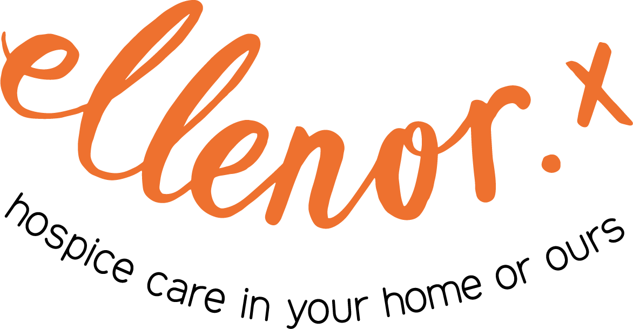

CLINICAL Training

July 2025

Contents
Who are we? 3
Our Services 3
Our Mission 3
Training and Education 4
Setting Up a Syringe Driver - For Registered Nurses 5
Symptom Control 7
Drug Calculations 8
Medications Used In Palliative Care 9
The ReSPECT Process and Do Not Attempt Resuscitation 11
Communication 13
Advance Care Planning 14
Recognising and Care of the Dying Patient 15
Verification of Expected Death 16
Well-being and Self-care 17
End-of-Life champions 18
Supporting Grief, Loss and Trauma 19
No Barriers Here 20
We Will 21
Your Responsibility 21
Prices 21

Who are we?
ellenor is a specialist palliative care provider for adults and children in Dartford, Gravesham and Swanley, and children across West Kent and the London Borough of Bexley.

Our Services
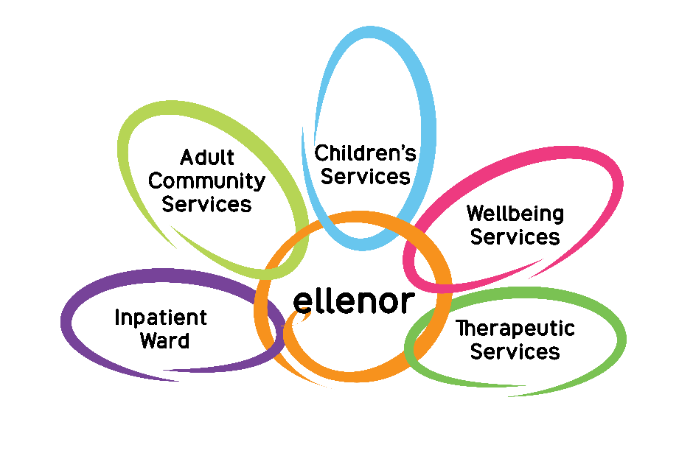

Our Mission
To lead and coordinate the best personalised care for all ages, sharing our expertise to ensure that all families facing terminal illness get the right support in the best place possible, enabling them to make the most of the time they have.

Training and Education
Our commitment is to share our expertise to develop staff and services through teaching. We have a strong record of involvement with training programmes internally, locally, nationally, and internationally.
With a tradition of sharing our knowledge, ellenor is also able to offer bespoke training sessions on request for your team. If you cannot see a course listed that meets your needs, then please contact our Education Team on 01474 320007 or email education@ellenor.org
Most of our training sessions can be delivered either face-to-face or virtually. It is stated on the page when a course can only be delivered face-to-face. Ideally for virtual sessions, all the learners would be in the same room with a webcam on. This is so that the trainer can see that the material is being understood and that there are no issues.

Setting Up a Syringe Driver - For Registered Nurses
Session Time: 2 hours. This session is delivered face-to-face.

Recommendation - to attend the Drug Calculations session before this practical session.
Aim: To gain confidence in administering medications using a syringe driver.

Learning Outcomes:
- To have a practical knowledge of how to set up a syringe driver used in palliative care.
- To be familiar with the alerts and alarms and to be able to act promptly when these occur.
- To be aware of the nurse’s responsibilities in administering subcutaneous medications using a syringe driver.

Contents:
- Demonstration and practical exercise on how to set up a syringe driver used in Palliative Care.
- How to continue with the same prescription when a new line is required.
- Site selection.
- Ongoing checks and monitoring.
- Recognising Alerts and Alarms.
- MHRA warnings.
- Medications commonly used.
- Medicines Compatibility.
We can also offer comprehensive syringe pump competency assessments on our Inpatient Ward at the ellenor hospice. These sessions take place on a one-to-one basis and take 1½ hours.

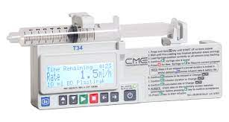
Image from bd.com

Symptom Control
Session Time: 2 hours.

Aim: To give a deeper understanding towards how to manage dying patients’ symptoms with a holistic approach, where to seek further help and advice.

Learning Outcome:
- To gain confidence in managing symptoms of the dying patient.
- To be able to advise patients/clients on how to manage symptoms without medications e.g. fan therapy.
Contents: How to manage
- Pain
- Breathlessness
- Nausea and vomiting
- Fatigue
- Agitation
- Respiratory secretions
This session will be looking at the Holistic Approach to Symptom Assessment and Management: Physical, Spiritual, Social and Emotional.

Drug Calculations
Session Time: 2 hours. This session is delivered face-to-face.

Aim: To gain understanding, awareness and confidence in conversions, calculations of medications given at End of Life to provide safe care.

Learning Outcomes:
- To be aware of the responsibilities of Registered Nurses with drug administration.
- To have a knowledge of formulas used to calculate the correct doses of opiates when converting from oral to subcutaneous medications.
- To understand the principles of bioavailability and duration of action.
- To recognise errors in prescriptions.
Contents:
- Calculation exercises to practice conversions.
- How to convert one opiate to another to achieve the correct dose required.
- How to use a conversion chart.
- A brief view of a syringe pump.
- Compatibility.
- What is Bioavailability and Duration of Action.
- The use of patches and moderate release opiates.

Medications Used In Palliative Care
Session Time: 2 hours.
Aim: To gain underpinning knowledge for medications used in palliative care.

Learning Outcomes:
- To be able to administer medications for End of Life, effectively.
- To comply with the Nursing and Midwifery Council Code of practice for safe delivery of care.
- To be able to communicate with the person, family and other Health Care Professionals in relation to medication needs for the individual.
- To be able to deliver safe, good care when administering medications.
- To understand the medications used and their side effects.
- To be able to reflect on practice.
Contents:
- Causes and management of symptoms from palliative to End of Life phase.
- Pharmaceutical and non-pharmaceutical approaches.
- Pain and the WHO ladder.
- Opiates and Opioids – patches, oral and sub-cutaneous medications.
- Vomiting and nausea and the vomiting centre.
- How to select the right medication.
- Use of steroids.
- What are adjuvant medications and how these can help.
- Toxicity.
- Depression – medication management and alternative therapies.
- Medication management of Breathlessness.
- Total Pain.



The ReSPECT Process and Do Not Attempt Resuscitation
Session Time: 1½ hours.
Aim: For all Health Care Professionals to be aware of the importance of having a conversation with their patient about their wishes in an emergency and resuscitation.

Learning Outcomes:
- To understand the process.
- To be able to fill in the form correctly.
- To care for as patient with a ReSPECT document.
- To consider the wishes of a patient in an emergency.
- To understand the Kent and Medway process.
- To recognise that people who are unlikely to survive after resuscitation attempts, can have the possibility of a peaceful and dignified death.
- To be aware of the importance of having a conversation about resuscitation and to understand what matters to the patient/client.
- To be aware of the legal and ethical issues.
Contents:
- What is ReSPECT.
- The form – description of each section.
- Emphasis on the recommendations for resuscitation.
- The process from start to finish.
- How to care for a patient with and without the document.
- Who to notify of the completed form.
- What is CPR.
- When and how to initiate the conversation.
- What is an Advance Decision to Refuse Treatment.
- The Law.
- Lack of Mental Capacity and Best Interest.
- Reviews.
- Documentation – The ReSPECT Process.
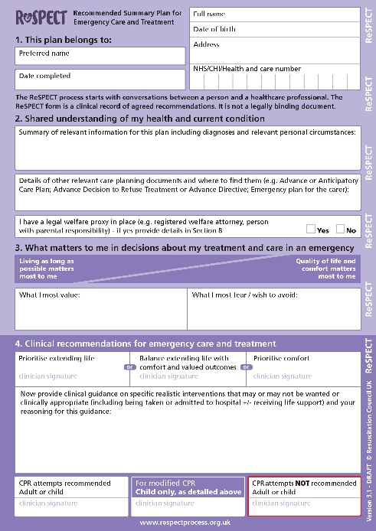

Communication
Session Time: 3 hours.
Aim: To provide all Health Care Professionals with an understanding of the concepts and skills required for good communication to take part in important and courageous conversations.

Learning Outcomes:
- Recognise different styles of communication.
- To appreciate the benefits of good communication.
- To critically reflect and monitor communication skills.
- To use a variety of communication skills.
- To develop a tool kit for communication.
- To communicate with patients with dementia for End of Life care.
Contents:
- Barriers to Communication skills.
- How to pick up on cues.
- What is empathy and how it is used in communication.
- Active listening.
- Breaking bad news.
- Verbal and non-verbal communication.
- Different communication methods.
- Difficult conversations.
- Role play.

Advance Care Planning
Session Time: 1½ hours.
Aim: To gain the skills and knowledge to begin advance care planning and discussion with patients/clients who are at the end of their life.

Learning Outcomes:
- To use communication skills to help patients/clients to identify what is important to them.
- To enable patients/clients to make informed choices.
- To identify the challenges involved with Advance Care Planning.
- To recognise the legal implications of Advance Decisions to Refuse Treatment.
- To be aware of reversible conditions.
Contents:
- What is Advance Care Planning.
- Talking about death and dying and fears about these conversations.
- Preferred place of death.
- Preferred place of care.
- DNACPR.
- Skills required for successful Advance Care Planning.
- Reviewing.
- What is a Treatment Escalation Plan.

Recognising and Care of the Dying Patient
Session Time: 2½ hours.
Aim: To increase confidence in identifying the last days and hours of life and recognise the signs of dying.

Learning Outcomes:
- Identify Signs of dying.
- Consider reversible causes.
- Explore ways to support someone who is dying.
- To provide comfort at End of Life.
Contents:
- Discussion on the meaning of dying.
- Psychological care for person and their families.
- Communication with family.
- Self-care for the family and professional.
- Physical signs of dying.
- Caring for the dying.

Verification of Expected Death
Session Time: 3 hours. This includes a competency assessment. This session is delivered face-to-face.

Aim: For Registered Professionals to be able to verify a death.

Learning Outcomes:
- Determine the physiological aspects of death.
- Have an understanding of the importance of communicating with staff, family and carers.
- Demonstrate an understanding of the clinical role and legal issues related to Verification of Death (VOED).
- To be clear on VOED Policy for own employing organisation.
- Describe the principles in context with scope of practice from the Nursing and Midwifery (NMC) Code of Practice or the Health & Care Professionals Council (HCPC) Standards of Proficiency.
Contents:
- What happens after death.
- The Law.
- Recognising Dying.
- What is an expected death.
- The Verification Process.
- Communication – Breaking bad news.
- Documentation.

Well-being and Self-care
Session Time: 2½ hours.
Aim: To recognize the importance of maintaining well-being and to recognise the importance of self-care for carers.

Learning Outcomes:
- A holistic approach to achieve an overall wellness, including physical, emotional, spiritual and social well-being.
- For Health Care Professionals to recognise the importance of self-care so as to avoid “burn out”.
- To identify and accessing additional resources to provide support.
Contents:
- Recognise stress and anxiety.
- What is “burn out” and where to seek help.
- What is quality of life.
- Resilience.
- Team working.

End-of-Life champions
Session Time: 2 x 4 hours.
Aim: To empower all Health Care Professionals to support their teams through patient end-of-life care with dignity and respect, whilst also supporting families.
Learning Outcomes:
- Develop communication skills to empower the health care professional to initiate conversations around death.
- To understand medications.
- To support the wishes of the patient.
- To assess, plan and provide person-centred care.
- Spiritual care.
- Identifying the dying patient.
Contents:
- Advance care planning.
- Medication.
- Communication.
- Nutrition and hydration.
- Holistic assessment.
- Self-care.
10-12 people per session.

Supporting Grief, Loss and Trauma
Session Time: 4 hours.
Aim: To empower managers to effectively support their teams with bereavement and loss.
Learning Outcomes:
- To understand the words bereavement and grief.
- To learn and demonstrate active listening.
- How to plan support.
- Signposting.
- How to promote a positive culture.
- Identify signs of bereavement and grieving.
Contents:
- Assessment methods:
- group activity, targeted questions, team quizzes, role play.
Maximum of 10 people per session.



No Barriers Here
Session Time: 3 x 2½ hours. This training takes place over 3 sessions, with a 2-week interval between each session. We will provide all the required materials.


No Barriers Here is a unique and innovative approach to Advance Care Planning for people who experience inequality accessing palliative and end-of-life care.
Aim: To build relationships and deepen conversations using art-based methods to facilitate discussion, rather than educating people.
Learning Outcomes:
This training helps to build strong relationships with all local communities and empower clients to access wider health support. The training is transferrable to all groups of people.
Contents:
- Who am I and what is important to me?
- Where would I like to be cared for and how?
- What are my funeral plans?
- How would I like to be remembered?

We Will
Provide certificates for individuals attending the relevant sessions.

Your Responsibility
It is the responsibility of the individual organisations to:
- Ensure policies and processes are in place.
- Ensure competencies are assessed.
- ellenor can assess an individual representative from an organisation - to enable this individual to carry out assessments in this individual’s place of work.
- Skills assessments – will be classroom based and dependent on safe systems/processes in place for the individual organisation.
- To arrange this please contact education@ellenor.org

Prices
Please contact education@ellenor.org for a quote.

