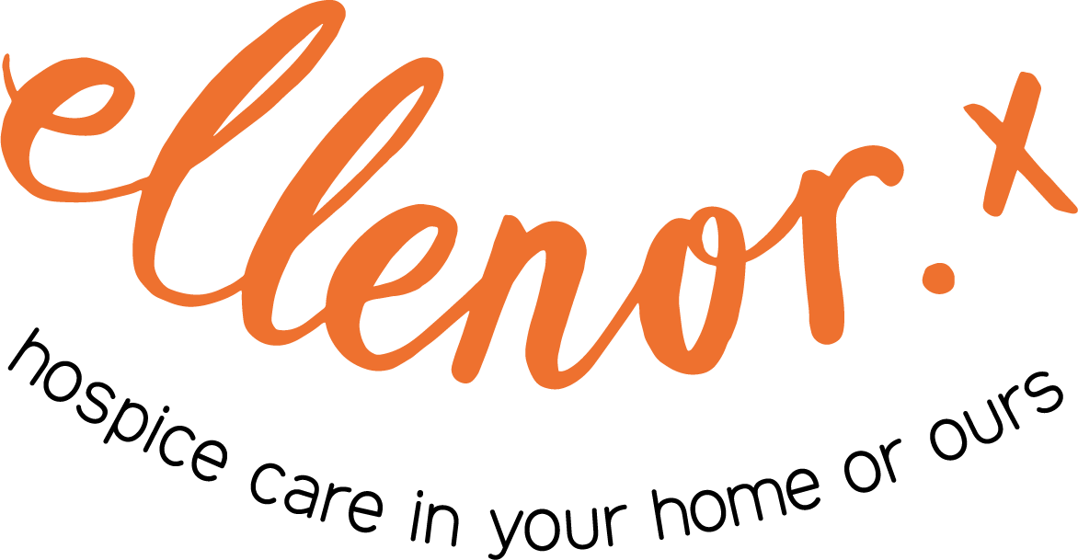

Non-Clinical Professional Training

July 2025

Contents
Who are we? 2
Our Services 2
Our Mission 2
Training and Education 3
Communication 4
Well-being and Self-care 5
Bereavement 6
Supporting Grief, Loss and Trauma 7
We Will 8
Your Responsibility 8
Prices 8

Who are we?
ellenor is a specialist palliative care provider for adults and children in Dartford, Gravesham and Swanley, and children across West Kent and the London Borough of Bexley.

Our Services
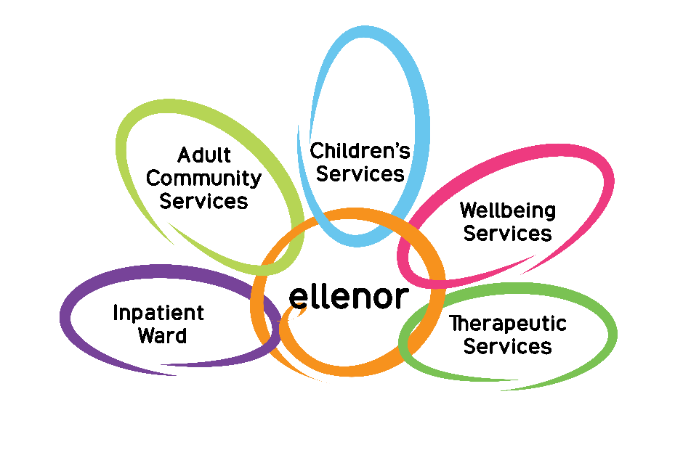

Our Mission
To lead and coordinate the best personalised care for all ages, sharing our expertise to ensure that all families facing terminal illness get the right support in the best place possible, enabling them to make the most of the time they have.

Training and Education
Our commitment is to share our expertise to develop staff and services through teaching. We have a strong record of involvement with training programmes internally, locally, nationally, and internationally.
With a tradition of sharing our knowledge, ellenor is also able to offer bespoke training sessions on request for your team. If you cannot see a course listed that meets your needs, then please contact our Education Team on 01474 320007 or email education@ellenor.org
Most of our training sessions can be delivered either face-to-face or virtually. It is stated on the page when a course can only be delivered face-to-face. Ideally for virtual sessions, all the learners would be in the same room with a webcam on. This is so that the trainer can see that the material is being understood and that there are no issues.

Communication
Session Time: 3 hours.
Aim: To provide all Health Care Professionals with an understanding of the concepts and skills required for good communication to take part in important and courageous conversations.

Learning Outcomes:
- Recognise different styles of communication.
- To appreciate the benefits of good communication.
- To critically reflect and monitor communication skills.
- To use a variety of communication skills.
- To develop a tool kit for communication.
- To communicate with patients with dementia for End of Life care.
Contents:
- Barriers to Communication skills.
- How to pick up on cues.
- What is empathy and how it is used in communication.
- Active listening.
- Breaking bad news.
- Verbal and non-verbal communication.
- Different communication methods.
- Difficult conversations.
- Role play.

Well-being and Self-care
Session Time: 2½ hours.
Aim: To recognize the importance of maintaining well-being and to recognise the importance of self-care for carers.

Learning Outcomes:
- A holistic approach to achieve an overall wellness, including physical, emotional, spiritual and social well-being.
- For Health Care Professionals to recognise the importance of self-care so as to avoid “burn out”.
- To identify and accessing additional resources to provide support.
Contents:
- Recognise stress and anxiety.
- What is “burn out” and where to seek help.
- What is quality of life.
- Resilience.
- Team working.

Bereavement
Session Time: 2½ hours.
Aim: To understand Bereavement and Loss.

Learning Outcomes:
- To be aware of the effects of grief and loss.
- To support patients/clients and their families.
- To be aware of how deaths of patients/clients affect the staff.
- To be able to access help and the importance of referrals to services that are experienced in providing support.
Contents:
- The theories of bereavement and loss - the 5 stages of grief.
- The effects of loss and grief.
- Model of coping.
- Complicated grief.
- Where to access help – sign posting.
- Culture and grief.

Supporting Grief, Loss and Trauma
Session Time: 4 hours.
Aim: To empower managers to effectively support their teams with bereavement and loss.
Learning Outcomes:
- To understand the words bereavement and grief.
- To learn and demonstrate active listening.
- How to plan support.
- Signposting.
- How to promote a positive culture.
- Identify signs of bereavement and grieving.
Contents:
- Assessment methods:
- group activity, targeted questions, team quizzes, role play.
Maximum of 10 people per session.



We Will
Provide certificates for individuals attending the relevant sessions.

Your Responsibility
It is the responsibility of the individual organisations to:
- Ensure policies and processes are in place.
- Ensure competencies are assessed.
- ellenor can assess an individual representative from an organisation - to enable this individual to carry out assessments in this individual’s place of work.
- Skills assessments – will be classroom based and dependent on safe systems/processes in place for the individual organisation.
- To arrange this please contact education@ellenor.org

Prices
Please contact education@ellenor.org for a quote.

